
Supported by:
Delivered by:

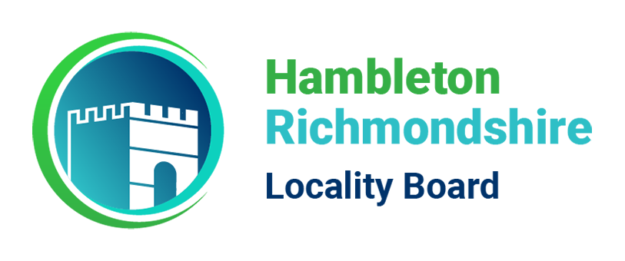

What is the Autism Project? | The Autism Project is a project funded by Hambleton & Richmondshire locality board to support the needs of autistic children and young people in mainstream schools in Hambleton and Richmondshire.  The Autism Project is offering a free advisory service to schools within the Hambleton and Richmondshire locality.
Who is the advisory service for? | Children and young people with communication and interaction needs, with or awaiting an autism diagnosis, who attend mainstream EYFS or primary provision within the locality area of Hambleton & Richmondshire. The service also aims to support settings in providing training for their staff.  We are a complimentary service as part of the Autism Project run by H&R Locality Board, running through academic year 2023-24.  *See website – coming Autumn 2023!*
What support do we offer?

We offer general advice and consultancy on the current concerns and challenges within your setting.
We offer autism specific training in response to an identified need on a small group or whole school basis.

Examples of what we can offer:

- General advice on current concerns and challenges.
- Staff training on a small group or whole school basis.
- Workshops for teaching assistants
- Modelling and coaching on the use of complementary resources.
- Modelling and coaching on evidence- based interventions and approaches.
- Signposting to services and resources.
- Guidance on quality first teacher and modelling of good autism practice.
- One to one coaching for teachers to support implementing good autism practice.
- Telephone consultation
- Transitional support
- Guidance within the graduated response.
- Guidance on writing SEN Support plans
- Workshops for families

Please download and complete the referral form below and return to autismprojectreferrals@thedalesschool.org

Setting Details

Name of point of contact

Job Title

Email Address

Phone Number

Name of setting

Address

Type of provision |  | EYFS |  | Primary |  | Primary TMP
Which key stage does this referral relate to?

EYFS | Key Stage 1  (Y1/2) |  | Key Stage 2 |  | Whole school

Please briefly outline the current concerns and/or challenges that your setting is
currently experiencing that relate to this referral.

What evidence do you have of interventions / strategies which have already been tried?
(This can be evidence from other settings)
What do you feel you need beyond what expertise is already available in your setting?
(This can be discussed in further detail during initial contact)
Have you already accessed any training offered by the Autism Project?
Training offered by Autism Project | Accessed (yes/no) | If yes, has this been of benefit to your setting in relation to the current referral (yes/no)
Unlocking Autism
Think Sensory, Not Behaviour – Sensory processing training
Brick by Brick – Lego therapy
Social Stories training
(running Sept 23)

Accepted referrals will receive an initial phone call to discuss pathway of support. Support will be allocated accordingly under the discretion of the project lead and the project officer.

